OU Club of Tulsa
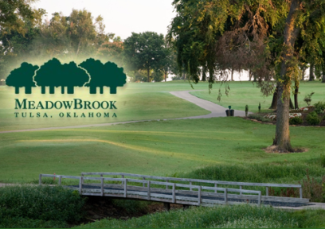
15th Annual
Scholarship Golf
Tournament
Meadowbrook Country Club
Monday, July 16th
8:00 a.m. Shotgun Start

Sponsor Registration Form

□ THE CRIMSON SPONSOR ($200.00) Each Crimson Sponsor will have (1) Tee Box Sign placed at a designated hole ($175 Deducible) and will receive recognition on all tournament promotions.
□ THE CREAM SPONSOR ($250.00) Each Cream Sponsor will have (1) Tee Box Sign placed at a designated hole, (1)
($210 Deductible) Banner Sign placed at the entrance of the golf tournament, and will receive
recognition on all tournament promotions.

CONTACT INFORMATION:

FIRST NAME: ___________________________ LAST NAME: _____________________________

BUSINESS NAME AS YOU WISH IT TO APPEAR ON THE SIGNAGE:

______________________________________________________________________________________

WORK NUMBER: __________________________ CELL PHONE: ___________________________

EMAIL ADDRESS: ____________________________________________

STREET ADDRESS: ________________________ CITY: ______________ STATE:______ ZIP:___________

Sponsor entry forms and fees must be received no later than 7/1/18. You may register in two ways: 1. On our website at www.oucluboftulsa.com which will allow you to pay through the OU Foundation website by credit card or PayPal; or 2. Fill out this form, pay by check made payable to the OU Foundation, and mail to Jess Mitchell, OU Club of Tulsa Treasurer, 4502 E. 41st Street, Suite 3B11, Tulsa OK 74135-2512. For a portion of your sponsorship to be tax deductible the monies must be sent directly to the O. U. Foundation as above.

If you need more information, check our website www.oucluboftulsa.com under the “Events” page. If you have questions please contact Jess Mitchell, 918.237.1772, soonerjes@yahoo.com or Kyle Depew, 918.230.7940, kyle.b.depew@williams.com. We appreciate your help and consideration in providing scholarships for deserving students attending O.U.

